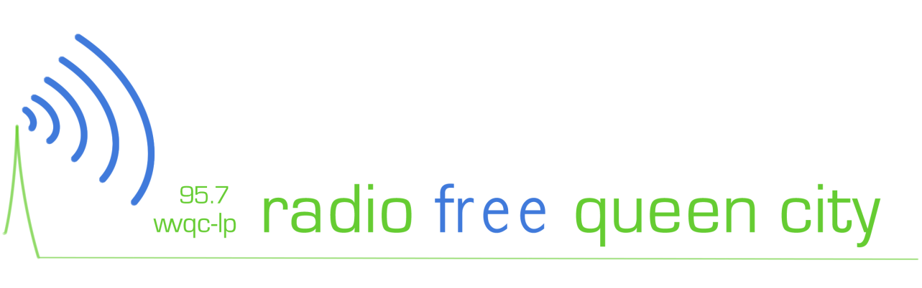

Independent, radio for the people by the people is coming to Cincinnati.
Here’s how you can get involved:

About WVQC
WVQC, Radio Free Queen City, is a non-profit, independent, low-power FM radio station operated by Media Bridges. WVQC will serve as a platform for local, diverse voices within Cincinnati’s communities, especially the urban core. WVQC is broadcasting online at wvqc.org and will be broadcasting on 95.7 FM early next year.

Become a Member
Support independent media and earn free perks, like stickers, t-shirts and tickets to events; become a member of WVQC. Members can host shows and take free training classes. Visit wvqc.org/member to sign-up for one our three levels:

- DJ: $30, Includes a free exclusive bumper sticker as our gift to you
- MC: $75, Includes a free t-shirt as our gift to you
- Mix Master: $150, Includes a free t-shirt and 2 free tickets to a WVQC event

Host a Show
WVQC is seeking talented local volunteers to produce and host radio shows. We’re looking for programs that are unique, high quality and locally produced. To submit an application, volunteers must be a member of WVQC and registered or certified in a training class.

Become an Underwriter
Want to let local listeners know about your business and support independent media at the same time? Underwrite a program on WVQC. Visit wvqc.org/underwrite to view our affordable rates and sign up.

Local Musicians
WVQC is building a library of local music to play on the air. Send your CDs to WVQC/ Media Bridges 1100 Race St. Cincinnati OH, 45202 to get on our playlist. For more information about WVQC visit wvqc.org, or call Media Bridges at 513-651-4171.

