BUILDING COMMUNITY THROUGH TECHNOLOGY
Fall
10
08
Fall

How to Publish Your Podcast

There are several steps to publishing a podcast for free:

- Create an Archive.org / Our Media account
- Upload your podcasts to Our Media
- Create a Blogger account for your podcast
- Post on your blog
- Log in to Feedburner
- Create a "Feed" for your podcast using Feedburner

1. Create an Archive.org / Our Media account

Storing your podcasts on the internet usually costs money, but Archive.org will provide anyone with free space for their media (music, movies, images, and of course podcasts).

Go to this web address: http://www.archive.org/account/login.createaccount.php

Fill out the form. Note: you will need a valid e-mail address to register.
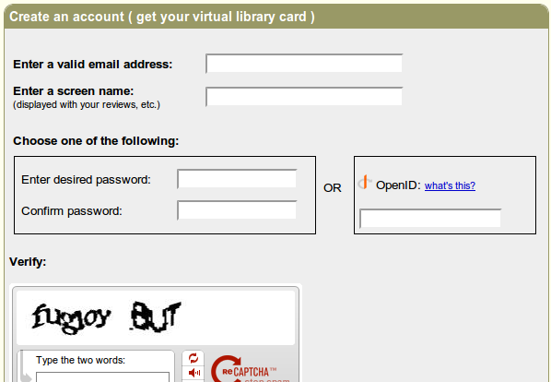
2. Upload your podcasts to Our Media

Next, go to Our Media. http://www.ourmedia.org/upload

Our Media and Archive.org are partners that work together to provide free space for people to upload and access media for free.

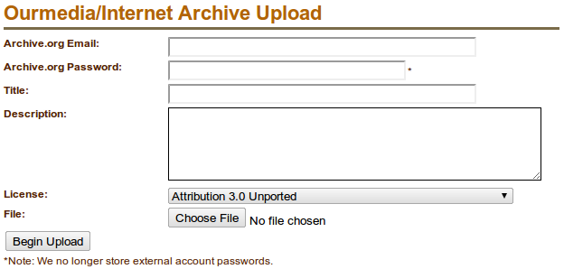
Complete the upload form.

Archive.org Email: this is the e-mail you used to register at Archive.org
Archive.org Password: this is the password you created at Archive.org
Title: give your podcast a title, probably the name of your show plus the episode title or date
Description: A short description of your podcast and episode.
License: You have a few options.
Public domain means anyone can distribute, use, or remix your podcast for free.
Attribution 3.0 – anyone can distribute or remix your stuff, but they have to "attribute" it to you, they have to give you credit
Attribution Noncommercial 3.0 – anyone can distribute or remix your stuff as long as they give you credit, but no one can use your work to make money
Attribution Noncommercial No Derivative Works – anyone can distribute your work, but they can't use it to make other works and they can't make money by distributing your work (they can't sell your podcast0
Attribution Noncommercial Share Alike – anyone can distribute or remix your work, but if they remix it, they can only distribute it under a similar license and can't make money from it
Attribution No Derivative Works – anyone can distribute your work or even make money off of it, but no one can remix it and they must give you credit
Attribution Share Alike – anyone can distribute or remix your work if they give you credit, but it has to be distributed under the "Attribution Share Alike" license
File: select your mp3/ogg file on your computer
Upload: click the button to upload!

Our Media will send you an e-mail containing the link to your uploaded file. Keep these e-mails in a safe place, as you will need them later.

3. Create a Blogger Account

Blogger is a free "blog" or online journal service. We can also use it to publish a list of our podcasts.

Go to: https://www.blogger.com

Click on the "Create Blog" button.

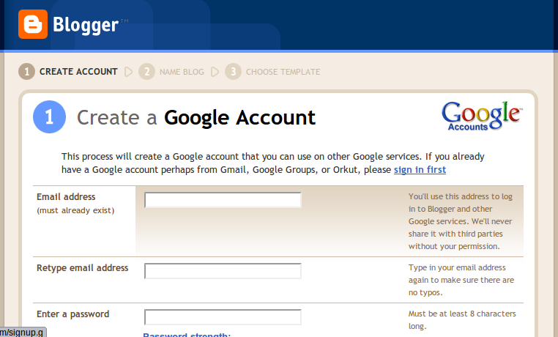
Complete the form.

Use the same e-mail that you used to sign up for Archive.org. Name your blog, choose your template (you can always change the template later), and then go to the Settings tab and then click the Formatting link:
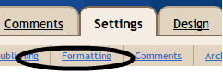

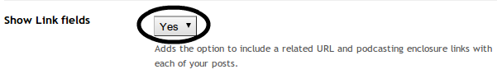
Scroll down and make sure the "Show Link" setting is set to "Yes." Then scroll down and click "Save Settings."

4. Post on your blog

Now, go to the Posting tab and click New Post. Every time you want to publish a podcast, you will create a new post. Give the post the same title as the podcast episode, then write a description of your episode in the body of the blog post.

Click the blue Link button to add a link to your podcast.

This link should be to the same link that Our Media e-mailed you – the one that points to your uploaded podcast file.

Then, publish your post. Your post will now appear on your blog. You could give people the link to your blog, but the standard format for subscribing to podcasts is called RSS feeds or "Really Simple Syndication." We need to make an RSS feed for your blog.

5. Log in to Feedburner

Some people make their RSS feeds by hand – but that can be a pain. We will use Feedburner to create our RSS feeds.

Go to: www.feedburner.com

Since Feedburner and Blogger are both owned by Google, you can use the same e-mail address and password to log in to Blogger and Feedburner.

6. Create a "Feed" for your podcast using Feedburner
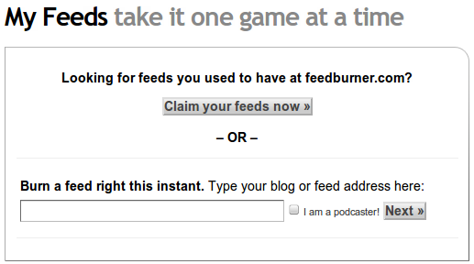
This is the main Feedburner account page:

Enter the URL of your blog (for example, myblogname.blogspot.com). This is the same address that you tell people when they want to visit your blog.

Check the "I am a podcaster!" box, then click Next.

If, prompted, select the "Atom" feed and click Next.

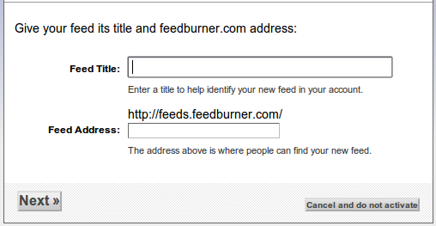

Now type in the title for your feed (the name of your podcast). Then, type in an address for your feed. For example, if your podcast was called "My Great Podcast," then you would type mygreatpodcast into the feed address box. People will use your feed address to subscribe to your podcast using their iPod or computer.

Once you complete this process, feedburner will create your RSS feed. You can now share this feed with friends and family – and you can use this RSS feed to promote your podcast on the web, at the iTunes store, and more.

