BUILDING COMMUNITY THROUGH TECHNOLOGY
Fall
10
08
Fall

How to Record in Audacity

1.) Plug the microphone and headphone into the computer.

2.) Open Audacity.

3.) The first thing you have to do is check your recording level. To see what your recording level is, you have to put the record meter into monitoring mode. Click the arrow next to the small microphone icon, and select Monitor Input, as shown.

*If you’re still not seeing any level, you may need to check your Audacity Preferences to make sure Audacity is configured to use your preferred audio device.
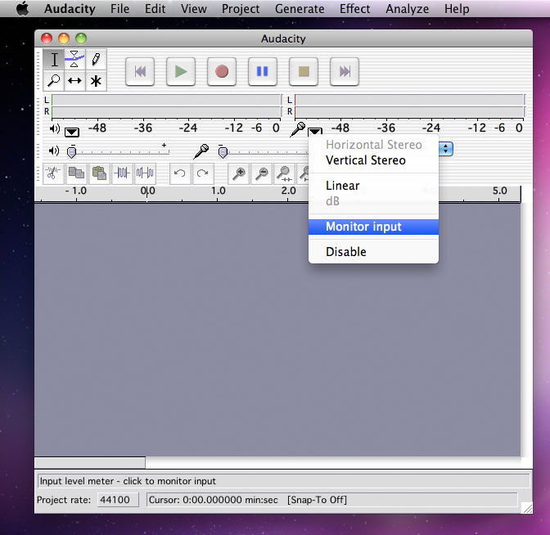
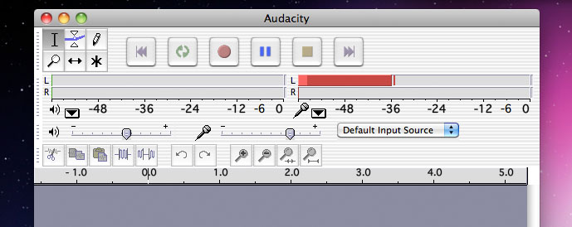

4.) Adjust the level of your microphone by sliding the microphone mixer control until your input level is peaking in the -12 to -6dB range.

5.) When you’re ready to begin, click the red record button on the Control toolbar. It usually takes Audacity a moment to start recording, so wait until you see an audio track appear and a cursor moving across the screen. It’s a good idea to begin each recording with a countdown, something as simple as “3...2...1...” will do just fine.

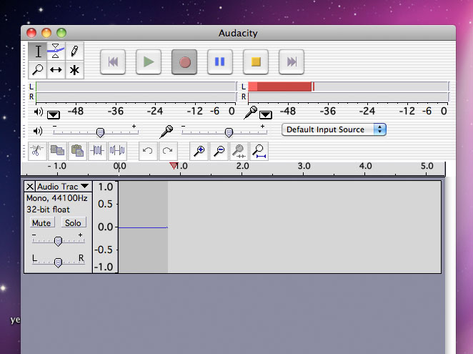
6.) If you make a mistake, don’t worry. You can edit it out later. The thing to remember is to pause before you start talking again, so you have a good place to edit.

7.) When you’ve had your say, stop the recording by clicking the yellow stop button. Save your project by selecting Save Project from the File menu.

